Improvement of Global Landcover Maps - the Geo-Wiki Project - Competition has started!!

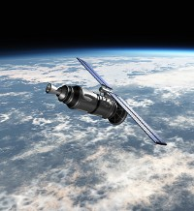**A new web tool has been developed to help improve the accuracy and extent of land use and forest cover information.**

The **Geo-Wiki Project** is a global network of volunteers who wish to help improve the quality of global land cover maps. Since large differences occur between existing global land cover maps, current ecosystem and land-use science lacks crucial accurate data (e.g. to determine the potential of additional agricultural land available to grow crops in Africa). **Volunteers** are asked to review hotspot maps of global land cover disagreement and determine, based on what they actually see in Google Earth and their local knowledge, if the land cover maps are correct or incorrect. Their input is recorded in a database, along with uploaded photos, to be used in the future for the **creation of a new and improved global land cover map**.

**We are pleased to announce that** the development team led by the International Institute of Applied System Analysis (IIASA) in Austria launched a **NEW Geo-Wiki Competition** to raise awareness and to encourage community involvement in environmental monitoring.

As an incentive we offer co-authorship of a research paper based on the competition results for the top 10 participants (based on a quality assessment and number of validations) and Amazon vouchers (totaling 75 Euros) for the top three participants! The competition will end on the 30th of March, 2012.

If you would like to participate in the competition please go to: <http://competition.geo-wiki.org/login.php>

Detailed instructions are available on the site.  
  
Kind regards,

The Geo-Wiki Team

APOLOGIES FOR CROSS-POSTING